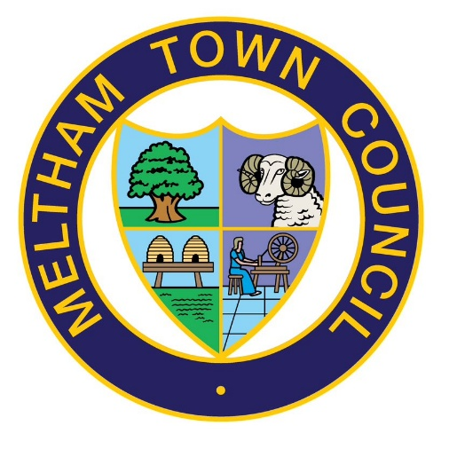 | MELTHAM TOWN COUNCIL  SHOP FRONT AND CCTV  GRANT SCHEME  APPLICATION FORM

PLEASE USE THIS APPLICATION FORM TO APPLY FOR OUR SHOP FRONT OR CCTV GRANTS.

PLEASE SEE BELOW FOR FULL GUIDANCE IN COMPLETING YOUR APPLICATION AND THE RELEVANT CRITERIA REQUIRED -:

Shop Front & CCTV Guidance & Criteria

Meltham Town Council Shop Front and CCTV Grant Scheme can be used for the following -:

- Improve the look of your business, restore the character of a building and help enhance your high street
- Shop Front Grants, apply for 50% of the cost of the works up to a maximum contribution of £2,500.00
- CCTV Grants, apply for 50% of the cost of the equipment up to a maximum contribution of £250.00 – *businesses must ensure they are GDPR compliant when capturing personal data and use clear signage for the CCTV stating its purpose*.

Applicant’s details
Shop Name

Address of premises

Contact name

Contact address for correspondence if different from above

Telephone | Home:  Mobile:
Email address

What is the nature of the business at the premises you are applying for?

Are you applying for the Shop Front or CCTV Grant Scheme?

Status
Are you? | √ | Please send in with your application
Owner /Occupier |  | Proof of ownership e.g. land registry entry
Landlord |  | Copy of Lease
Tenant |  | Copy of Lease and landlords written permission

VAT
Are you VAT registered? | √
Are you VAT registered? | Yes | No
If Yes, VAT registration number

Project Details
Please list the following items:
- How will the proposed works enhance the overall appearance of the town centre?
- How do the proposed works meet the Town Councils design guidance?
- Proposed works, including types of materials and colours
- When you propose to start the works?
- How long will the project take to complete?
- Will the project go ahead without grant funding?
Use additional sheets of paper if necessary and attach to the application.

Estimated cost of work as per selected contractor(s):
Contractor | Item | Cost
Sub total  VAT  Full project cost |  | £
 |  | £
 |  | £
Amount of grant requested  (please note if VAT registered the grant should be calculated on net costs) |  | £

Please attach 2 quotes for each element of work to be undertaken.
Additional Project Information:
Do you or the business have any financial interest in any company who has provided any of the quotation provided with this application? If the answer is yes, then the grant aid will be limited to material costs only | √
 | Yes | No

Planning:
To apply for this grant scheme, you must have received pre-application advice from Kirklees Council’s Planning department

Pre application advice reference number
Pre application advice reference number | √
Does your project require planning permission? | Yes | No
Does your project require any other permissions? | Yes | No
If your answer is YES to either, please attach a copy of all the permissions you require

Checklist:
I have enclosed (please tick all relevant boxes) | √
Proof of ownership if owner / occupier
Copy of lease if landlord / tenant
Landlord’s permission
Planning permission(s)
Two quotes for each item of work (like for like quotes and specification if available)
Photograph of the existing shop front
Plans and drawings of what the shop front will look like when the works are complete if available. Please show details including colour and design
Confirmation that the property is located within the Meltham conservation area (see maps)

Publicity:
All successful applications will be publicised in the Town Councils newsletter and on its website. By accepting any grant you agree to this publicity and also agree to displaying a poster in the shop window or within the reception area of the business (to be supplied by Meltham Town Council) for 12 months following the completion of the works to the shop frontage acknowledging the grant from the Town Council

Declaration and signature:

- I have read and understood the terms and conditions of the grant
- I undertake to advise the Council of any changes to the details contained in this application
- I declare that all the information I have supplied on this form in correct and that any false declarations may invalidate my application
- If my application is successful I agree to it being publicised in the Town Councils newsletter and on its website and also agree to displaying a poster for 12 months following the completion of the works to the shop front acknowledging the grant from the Town Council

Signature of applicant |  | Position
Print name |  | Date

Please return the completed form to:
The Town Clerk
Meltham Town Council
The Carlile Institute Meltham
HD9 4AE
or email
townclerk@melthamtowncouncil.gov.uk

Please note your application cannot be processed unless it is fully completed, and all the necessary documentation is enclosed

Privacy:
The information you provide will only be used for the purposes of processing the grant application and will be processed in accordance with the law. For details of our privacy policy please visit our website Privacy & Cookie Policy.

